Pondhu Primary School
Penwinnick Road, St Austell, Cornwall. PL25 5DS
Headteacher: Debbie Tregellas B.Ed.
Deputy Headteacher: Sarah Parekh B.Ed.
T: 01726 74550 www.pondhu.eschools.co.uk

12th January 2021

Dear Parents and Carers,

LAPTOPS FOR SCHOOL SCHEME

The Government are running a scheme to provide a laptop for those pupils who do not have digital access to home learning. It may also support those families who have to share a single device in a household with more than one child.

More information can be found if you follow this link to the scheme https://www.gov.uk/guidance/get-laptops-and-tablets-for-children-who-cannot-attend-school-due-to-coronavirus-covid-19

If this is something you think your family is entitled to, please use the LAPTOPS link or the QR code below to complete a brief survey to provide us with information to complete the application on your behalf. Please ensure this is completed no later than 12 noon on Wednesday 15th January, to enable us to submit the application swiftly.

We would be thrilled if some of our families managed to get this support, however, there is no guarantee that our request will be successful.
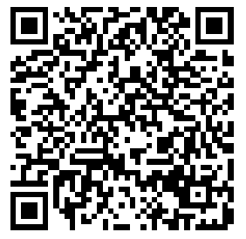
Yours faithfully,
LAPTOPS

Mrs D Tregellas
HEADTEACHER

