M-8 ~ Positive Relationships and Behaviour Policy

Date of Last Review: | July 2022
Date of Next Review: | July 2023

Our school is a safe, respectful learning environment

INTRODUCTION

‘Good behaviour in schools is central to a good education. Schools need to manage behaviour well so they can provide calm, safe and supportive environments which children and young people want to attend and where they can learn and thrive. Being taught how to behave well and appropriately within the context they’re in is vital for all pupils to succeed personally.’
(Behaviour in schools DFE 2022)

At Pondhu Primary school we seek to create and provide an environment in which effective teaching and learning can take place. We have high expectations for our children in both their learning and their behaviour. We work to create a positive learning environment within the school, that ensures our approach to behaviour management is consistent, and understood by all the staff, pupils and parents.

Positive behaviour is promoted through our Personal, Social, and Health Education (PSHE) curriculum. We understand that all behaviour is a form of communication and poor behaviour is understood to result from an unmet need. Staff will work with children to identify the need and provide appropriate support to remove these barriers to successful engagement in school life. At Pondhu Primary School, we support children to reflect on experiences and understand the impact of behaviour on others and the wider community.

PURPOSE

The school aims to:

- provide consistency in our approach to understanding and managing behaviour
- ensure high standards of behaviour are in place, allowing all learners to make
good progress and reach their full potential
- foster a partnership between all members of the school community to promote high expectations of behaviour
- ensure school is a safe environment for all pupils, staff and visitors

EXPECTATIONS

All staff are expected to model positive learning behaviour and support the children in their understanding of the school’s ‘six golden rules’.

All pupils’ are expected to follow the school’s ‘six golden rules’ and demonstrate positive learning behaviours.

All parents/carers are expected to support the school’s ‘Positive Relationships and Behaviour policy’.

SCHOOL SYSTEMS

CONSISTENCY IS KEY

All staff in school need to address behaviours in a consistent manner. Children need consistency in how they are addressed in their behaviour for both positive and negative behaviours. In order to support staff with this staff must follow The Script when addressing poor behaviour. The Script enables staff across the entire school to have a clear structure behind them when it comes to talking to a child about their behaviour. Staff know what to do when and how to address behaviours by following the script. Please see Appendix A

GOLDEN RULES

Our Golden Rules apply everywhere within the school and at all times of the school day. These are reflected in the ‘good choices’ that apply to everyone:

We listen
We are gentle
We are kind and helpful
We look after property
We are honest
We work hard

At the start of every year, children will revisit the golden rules, understand the expectations of these and what that looks like in classrooms and around school.

ROUTINES

A consistent and orderly school day provides a supportive environment in which all children can learn to manage their feelings, emotions and behaviour. It fosters opportunities for children to learn and removes many barriers to learning. We believe all members of staff at Pondhu Primary School have a duty of care to strive to provide:

• A tidy, supportive, stimulating and celebratory environment
• An organised classroom which meets children’s basic needs and enables independence in self-support, e.g. a readily available range of resources
• Consistent, timetabled routines for the day which reduce lost learning time and are clearly understood by the children. Punctual break times and lunches which are well managed by adults who are on duty. When changes to class routines are needed, the children are given notice of this in advance, whenever possible.
• Transitions (movement) around the building are conducted in an orderly and calm manner.
• Assemblies are provided as a time for reflection, learning, celebration and exploration. Adults to model expected behaviour and manage that of the children in a calm and consistent manner.

TRANSITIONS

The most effective educators manage transitions well. Some basic examples of transitions are:

- Moving from carpet to table activities
- Moving between one learning experience to another
- Moving between classrooms / hall / learning spaces
- Going out to and coming in from an event such as play time
- Entering / exiting the classroom / learning space etc.

Transitions and changes of activity can make people feel stressed and uneasy. Therefore, all transitions between key learning experiences must be well planned and show an awareness of child’s individual needs. Learners will benefit from being given a clear warning or countdown to change ahead of time. Other strategies could include the use of familiar music cues, visual timetables and /or timers.

STRATEGIES

REWARDS

The staff should recognise that positive encouragement promotes good behaviour in pupils and helps to raise their self-esteem.

We praise and reward children for good behaviour in a variety of ways:

- adults give verbal praise
- stickers / certificates
- class dojo points
- notes / phone calls home
- achievement / celebration assemblies
- weekly star learners for each class
- class rewards for collectively achieving recognition target
- sharing achievements with a member of SLT

SANCTIONS

Children need to be able to trust that when agreements are broken, there are processes in place to repair harm, ensure that those harmed feel safe and able to learn and support those who have broken agreements to ensure there are not ongoing difficulties. Therefore a developmentally appropriate sanction may be required in order to address misbehaviour.

Staff will follow a progressive procedure for dealing with misbehaviour:
(See Appendix A)

- Verbal reminder
- Warning and a minute (positive attention for a minute)
- Script and last chance to turn it around
- Learning Zone (Triage)
- Senior Leadership Team

All incidents of misbehaviour will have a restorative follow up.

MORE SERIOUS SANCTIONS

Behaviour that is considered severe and is having a serious effect on learning and/or safety will immediately be brought to the attention of senior members of staff. This will lead to parents being contacted and relevant consequences issued.

All pupils are entitled to an education where they are protected from disruption and can learn in a calm, safe and supportive environment. The Government supports headteachers in using suspension and permanent exclusion as a sanction when warranted as part of creating a calm, safe, and supportive environment in which pupils can learn and thrive. (DfE ‘Suspension and Permanent Exclusion from maintained schools, academies and pupil referral units in England, including pupil movement’ July 2022)

Suspension and permanent exclusion can be used in response to serious incidents or in response to persistent poor behaviour which has not improved following in-school sanctions and interventions. The headteacher will use their own professional judgement based on individual circumstances when considering whether to suspend or permanently exclude a pupil.

A suspension may be used to provide a clear signal of what is unacceptable behaviour as part of the school’s behaviour policy and show a pupil that their current behaviour is putting them at risk of permanent exclusion.

A permanent exclusion is when a pupil is no longer allowed to attend school. The decision to exclude a pupil permanently will only be taken:

• in response to a serious breach or persistent breaches of the school's behaviour policy; and
• where allowing the pupil to remain in school would seriously harm the education or welfare of the pupil or others such as staff or pupils in the school

The headteacher will use the ‘Reasons and recording exclusions section’ within the (DfE ‘Suspension and Permanent Exclusion from maintained schools, academies and pupil referral units in England, including pupil movement’ July 2022) when deciding on circumstances that may warrant a suspension or permanent exclusion to occur.

The reasons below are examples of the types of circumstances that may warrant a suspension or permanent exclusion.

• Physical assault against a pupil
• Physical assault against an adult
• Verbal abuse or threatening behaviour against a pupil
• Verbal abuse or threatening behaviour against an adult
• Use, or threat of use, of an offensive weapon or prohibited item that has been
prohibited by a school’s behaviour policy
• Bullying
• Racist abuse
• Abuse against sexual orientation or gender reassignment
• Abuse relating to disability

Any consequences of misbehaviour will be in line with the school behaviour scale.

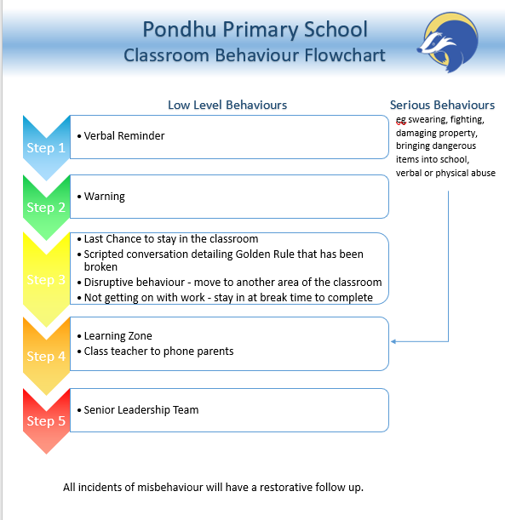

USE OF REASONABLE FORCE

There are circumstances when it is appropriate for staff in schools to use reasonable force to safeguard. Members of staff have the power to use reasonable force to prevent pupils committing an offence, injuring themselves or others or damaging property and to maintain good order and discipline at the school or among pupils.
Key members of staff are team teach trained and available to support if required.

RECORDING AND REPORTING

Behaviour incidents that occur are recorded by all members of staff. Staff will record incidents on CPOMS, an online tracking system which allows us to share information regarding incidents quickly.

When recording an incident it is important to ensure that all individuals involved have been heard and their comments noted. Actions should be decided from this depending on the severity of the incident. Actions leading to consequences for the child can be decided by the class teachers or members of SLT, with the Head teacher having the overarching decision.

It is the responsibility of all members of staff to record incidents and share information with the appropriate colleagues.

Incidents are recorded and monitored by SLT with any patterns noted. If patterns of behaviour occur this is raised at an SLT meeting in order to gauge what support can be offered or if any other professionals need to become involved.

ROLES AND RESPONSIBILITIES

STAFF RESPONSIBILITIES:

- Model positive, consistent, professional behaviour at all times
- Ensure good routines are in place and consistently applied
- Remain calm at all times
- Consistently seek out opportunities to reward positive behaviour choices
- Reinforce and model the golden rule expectations at all times
- Invest in ‘time in’ with a child to explain why certain behaviours do not meet our school expectations
- Recognise managing behaviour as a teaching opportunity and not simply a sanction
- Be alert to individual needs and if not known, seek support in managing a situation from an adult more closely known to the child
- Ensure consistency of the positive relationships and behaviour policy
- Always have high expectations
- Teachers will contact parents when a child is sent to the Learning Zone as a sanction for behaviour
- Always hold a restorative conversation with a child before they return to class

LEARNING ZONE PASTORAL STAFF RESPONSIBILITIES:

- Monitor patterns of behaviour and work towards preventing / reducing incidents
- Identify areas, children, times of concern and communicate these to staff as required
- Regular check ins with key children who require additional pastoral support
- Triage of children sent to the Learning Zone
- Support staff with restorative conversations
- Liaise with SENDCo / SLT to ensure needs of children are being met / appropriate sanctions are applied

SENIOR LEADERSHIP RESPONSIBILITIES:

- Support staff in implementing the policy
- Meet with parents when required
- Make decisions on most severe sanctions when needed
- Monitor effectiveness of the policy through consultation and regular self-evaluation
- Take action to address any areas for development

GOVERNORS

The governing body has the responsibility of monitoring standards of discipline and behaviour, and of reviewing their effectiveness.

STAFF INDUCTION

As part of the induction process, all staff will receive training on the school behaviour policy and expectations.

PUPIL TRANSITION

To ensure a smooth transition to the next year, children have transition sessions with their new teacher(s). In addition, staff have transition meetings.

PUPIL SUPPORT

The school recognises its legal duty under the Equality Act 2010 to prevent pupils with a protected characteristic from being at a disadvantage. Consequently, our approach to challenging behaviour may be differentiated to cater for the needs of the pupil.

The school’s SENDCo will evaluate a child who exhibits challenging behaviour to determine whether they have any underlying needs that are not currently being met.
Where necessary, support and advice will also be sought from specialist outside agency support, an educational psychologist, CELT SEND panel, medical practitioners and/or others, to identify or support specific needs.

When acute needs are identified, we will liaise with external agencies and plan support for the child. They will have a provision plan, a One Page Profile and a co-regulation plan. This will detail their goals and barriers to learning. All expectations around behaviour will take into account the provision plan and be personalised in line with the individual child’s needs. Although children with SEND may require the expectations in behaviour to be communicated in a personalised way, the zones of behaviour remain in line with those of others. At all stages, the root of the behaviour and its trigger points or setting factors should always be explored in order to support the child to get back to demonstrating Positive Learning Behaviours.

CONCLUSION

At Pondhu Primary school we aim to support children, as a whole-school community and as individuals, in making positive choices in their behaviour by outlining accepted boundaries and teaching children about the outcomes of their actions. We look to foster a happy, nurturing and supportive environment, and develop a strong sense of community in which everyone is valued and has the right to be safe and to learn.

POLICY REVIEW

This policy was reviewed in Summer 2022 by SLT and agreed by the RIG in September 2022. This will be reviewed by staff and governors in Summer 2023.

Links with other policies

This behaviour policy is linked to the following policies:
- E-safety policy
- Safeguarding policy
- PSHE policy
- CELT Exclusion policy

Legislation and statutory requirements:

This policy is based on advice from the Department for Education (DfE) on:
- Behaviour in schools July 2022
- Suspension and Permanent Exclusion from maintained schools, academies and pupil referral units in England, including pupil movement July 2022
- The School Discipline Regulations 2012
- Searching, screening and confiscation at school
- Ensuring good behaviour in schools
- The Equality Act 2010
- Use of reasonable force in schools
- Supporting pupils with medical conditions at school
- DFE Keeping Children Safe in Education 2021

It is also based on the special educational needs and disability (SEND) code of practice and ‘When the Adults change, Everything Changes’ – Paul Dix.

In addition, this policy is based on:
• Section 175 of the Education Act 2002, which outlines a school’s duty to safeguard and promote the welfare of its pupils
• Sections 88-94 of the Education and Inspections Act 2006, which require schools to regulate pupils’ behaviour and publish a behaviour policy and written statement of behaviour principles, and give schools the authority to confiscate pupils’ property
• DfE guidance explaining that maintained schools should publish their behaviour policy online

APPENDIX A

Behaviour Scale

- Reminder – Class teacher / TA – A child will receive a reminder for their behaviour if they are not following the 6 golden rules
- Warning and a minute – Class teacher / TA - A child will receive a second reminder alongside positive attention to try to engage the child and get them back on track.
- Last chance script - Class teacher / TA
LAST CHANCE SCRIPT

I’ve noticed that you are …(e.g. having trouble getting started, wandering around the classroom, not focussed on your learning)

The golden rule that you struggled to follow is …….. (name the golden rule)

Given the choice that you are making, you will now…

Disruptive behaviour – move to another place in the room
Not completing work – stay in at playtime to complete work

Do you remember when you (received a dojo, star learner, completed a great piece of work)…that’s the (name) I want to see today.

Thank you for listening.

- Learning Zone (Triage) If a child continues to cause disruption in learning, they will leave the classroom for the remainder of that lesson.

Parents will always be contacted by the class teacher when a child is sent to the learning zone as a sanction for behaviour.

Triage is a no-blame environment. Triage must answer the question ‘How can we return this child to their next lesson, calm and ready to learn?’

LEARNING ZONE TRIAGE
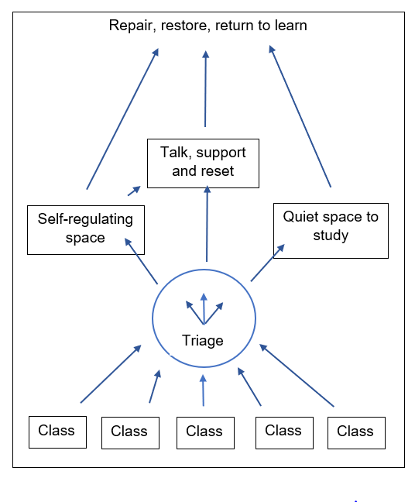

- Self-regulating space

This is a calm space where children can breathe and compose their emotions.

- Talk, support and reset

This is a 1:1 coaching conversation that supports the child to continue regulating and prepares them for the next part of their day

- Quiet space to study

A place to work for the lesson to show readiness to return to the next lesson.

At the end of the lesson the teacher / TA would go to the learning zone to have a ‘Restorative conversation’ before the child returns to class.

Reflection Questions – Teacher / TA

- What happened?
- What were you thinking at time?
- Who has been affected/how have they been affected?
- What should we do to put things right?
- How can we do things differently in the future?

For children who demonstrate repeated misbehaviours, there will be coaching which takes place with our pastoral leader, who reflects with the child on a deeper level. Question they will ask are:

Reflection Questions- Learning Zone pastoral support

- What have you thought about since?
- What strategies could you use to help you?
- Who could have helped you out in this situation?
- When/If you feel that way again, what could you do?

