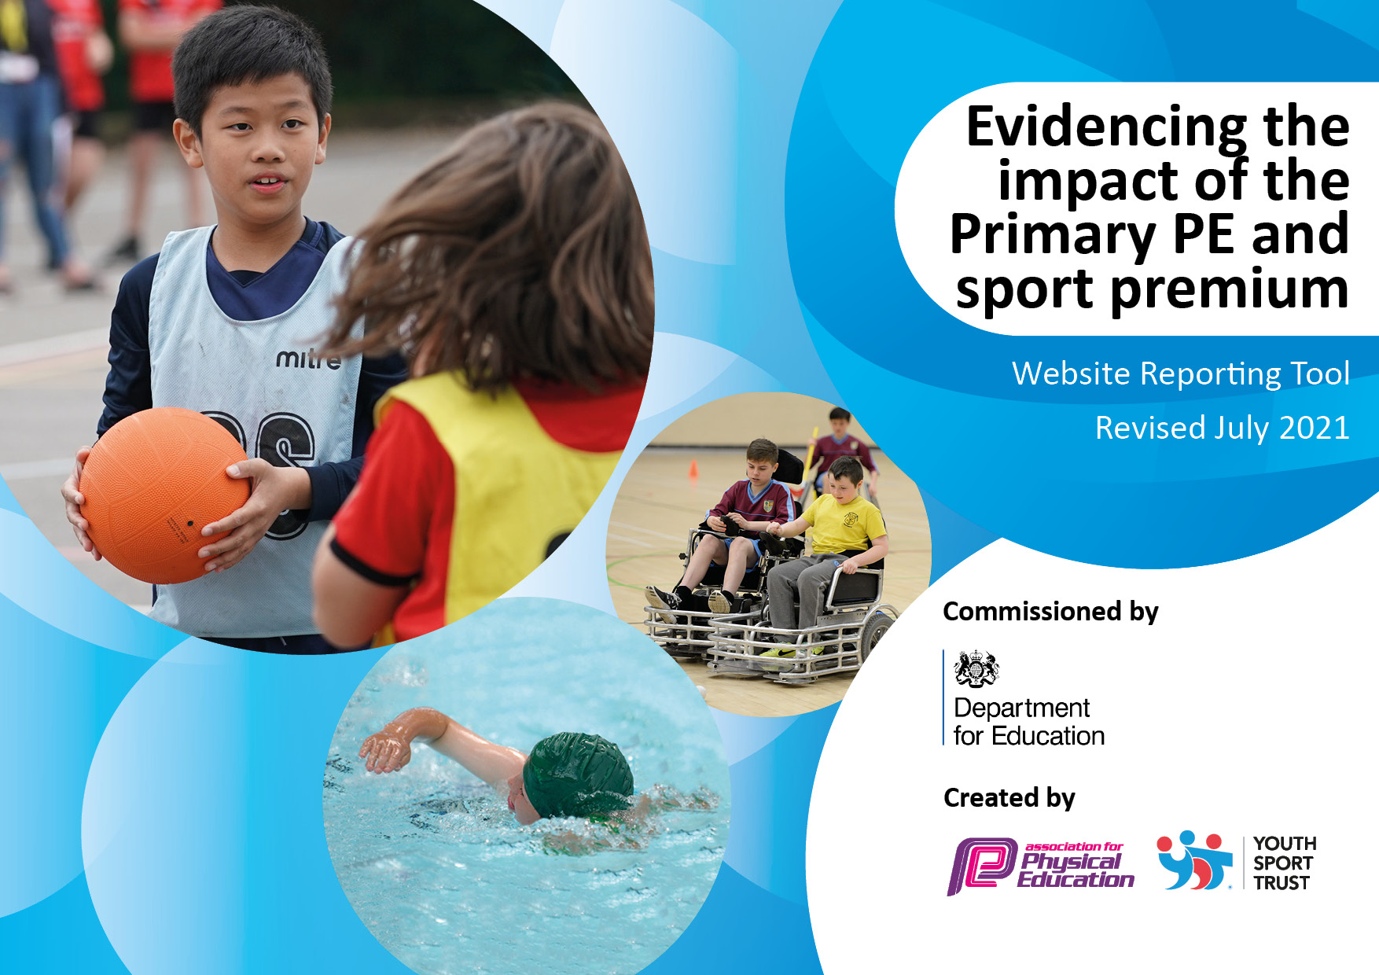
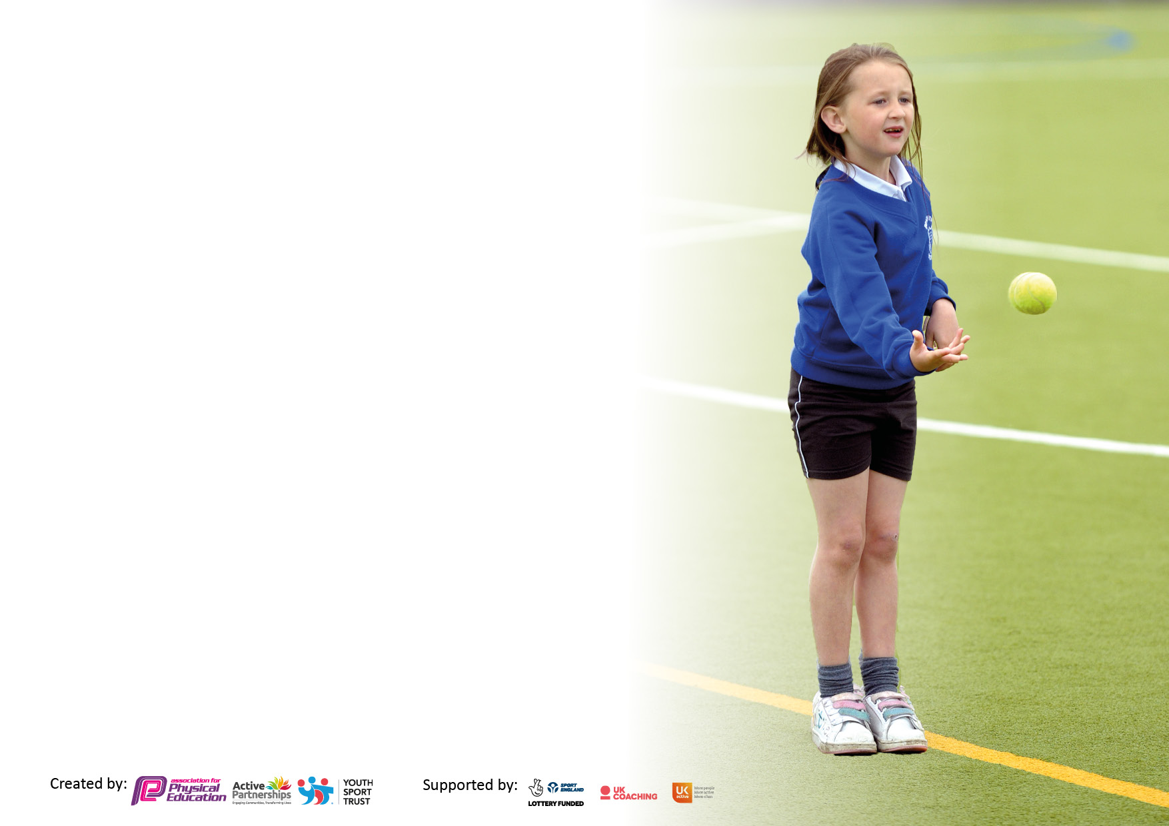

It is important that your grant is used effectively and based on school need. The Education Inspection Framework makes clear there will be a focus on ‘whether leaders and those responsible for governors all understand their respective roles and perform these in a way that enhances the effectiveness of the school’.

Under the Quality of Education Ofsted inspectors consider:
Intent - Curriculum design, coverage and appropriateness
Implementation - Curriculum delivery, Teaching (pedagogy) and Assessment
Impact - Attainment and progress

To assist schools with common transferable language this template has been developed to utilise the same three headings which should make your plans easily transferable between working documents.

Schools must use the funding to make additional and sustainable improvements to the quality of Physical Education, School Sport and Physical Activity (PESSPA) they offer. This means that you should use the Primary PE and sport premium to:

- Develop or add to the PESSPA activities that your school already offer
- Build capacity and capability within the school to ensure that improvements made now will benefit pupils joining the school in future years
- The Primary PE and sport premium should not be used to fund capital spend projects; the school’s budget should fund these.

Pleasevisitgov.ukfortherevisedDfEguidanceincludingthe5keyindicatorsacrosswhichschoolsshoulddemonstrate animprovement.Thisdocumentwillhelpyoutoreviewyourprovisionandtoreportyourspend.DfEencouragesschools to use this template as an effective way of meeting the reporting requirements of the Primary PE and sport premium.

We recommend you start by reflecting on the impact of current provision and reviewing the previous spend.

Schools are required to publish details of how they spend this funding, including any under-spend from 2019/2020, as well as on the impact it has on pupils’ PE and sport participation and attainment. All funding must be spent by 31st July 2023.

We recommend regularly updating the table and publishing it on your website throughout the year. This evidences your ongoing self-evaluation of how you are using the funding to secure maximum, sustainable impact. Final copy must be posted on your website by the end of the academic year and no later than the 31st July 2023. To see an example of how to complete the table please click HERE.

Details with regard to funding
Please complete the table below.

Total amount of funding for 2022/23. To be spent and reported on by 31st July 2023. | £18,010
Swimming Data
Please report on your Swimming Data below.

Meeting national curriculum requirements for swimming and water safety.

N.B. Complete this section to your best ability. For example you might have practised safe self-rescue techniques on dry land which you can then transfer to the pool when school swimming restarts.
Due to exceptional circumstances priority should be given to ensuring that pupils can perform safe self rescue even if they do not fully meet the first two requirements of the NC programme of study
What percentage of your current Year 6 cohort swim competently, confidently and proficiently over a distance of at least 25 metres?  N.B. Even though your pupils may swim in another year please report on their attainment on leaving primary school at the end of the summer term 2023  Please see note above | 57% (Summer 2022)
What percentage of your current Year 6 cohort use a range of strokes effectively [for example, front crawl, backstroke and breaststroke]?  Please see note above | 53% (Summer 2022)
What percentage of your current Year 6 cohort perform safe self-rescue in different water-based situations? | 53% (Summer 2022)
Schools can choose to use the Primary PE and sport premium to provide additional provision for swimming but this must be for activity over and above the national curriculum requirements. Have you used it in this way? | Yes

Action Plan and Budget Tracking
Capture your intended annual spend against the 5 key indicators. Clarify the success criteria and evidence of impact that you intend to measure to evaluate for pupils today and for the future.

Academic Year: 2022/23 | Total fund allocated: £11,000 | Date Updated: September 2022
Key indicator 1: The engagement of all pupils in regular physical activity – Chief Medical Officers guidelines recommend that primary school pupils undertake at least 30 minutes of physical activity a day in school |  |  |  | Percentage of total allocation:
 |  |  |  | 61%
Intent | Implementation |  | Impact
Your school focus should be clear what you want the pupils to know and be able to do and about  what they need to learn and to  consolidate through practice: | Make sure your actions to achieve are linked to your intentions: | Funding allocated: | Evidence of impact: what do pupils now know and what can they now do? What has changed?: | Sustainability and suggested next steps:
To employ a PE TA/Sports coach to further increase the school’s capacity for sports provision. | PE TA/Sports coach to run lunchtime clubs as well as afterschool clubs, to support the teaching of the PE curriculum and to encourage active play each playtime. | £10,000
To provide regular opportunities for all children including the least active (KS1 and KS2) to attend clubs which promote physical activity. | To encourage an ever-increasing number of children to attend clubs.  To monitor club attendance and target those not engaging. | £0
To develop leadership opportunities for Year 6 children to lead active play. | To train selected Year 6 children to be responsible for equipment and to encourage active play. | £0
To purchase new playground equipment | To purchase new equipment as needed. Current equipment use to be monitored and the playground store to be well organised, accessible and used appropriately. | £500
To purchase new PE equipment as needed. | To purchase new equipment as needed. Current equipment use to be monitored and the PE shed to be well organised, accessible and used appropriately. | £500
To continue to promote the use of Daily Mile across the whole school to help achieve the recommended 30 minutes of physical activity per school day, improve fitness levels and re-focus children on their learning. | To remind teachers of the expectation for all children to take part in the Daily Mile and share ideas of how to continue to encourage the children to be as active and engaged as possible. | £0
To encourage active travel to and from school by providing Bikeability training for children in Y5 and 6. | Bikeability training will be provided through the Poltair sports network. | £0
Key indicator 2: The profile of PESSPA being raised across the school as a tool for whole school improvement  £1500 |  |  |  | Percentage of total allocation:
 |  |  |  | 8%
Intent | Implementation |  | Impact
Your school focus should be clear what you want the pupils to know and be able to do and about  what they need to learn and to  consolidate through practice: | Make sure your actions to achieve are linked to your intentions: | Funding allocated: | Evidence of impact: what do pupils now know and what can they now do? What has changed?: | Sustainability and suggested next steps:
To join the Poltair Sports network. | Joining the Poltair Sports network will increase the number of children representing the school in school sport – with 6 tournaments/ sporting festivals each half term.  Competing in every event will raise the profile of the school locally.  A weekly sports report on the school newsletter will raise the profile further.  The numbers of different pupils representing the school to be monitored. | £1500
To encourage language development through the use of PE. | Encourage the use of verbal evaluations during PE lessons. Model how to do so effectively | £0

Key indicator 3: Increased confidence, knowledge and skills of all staff in teaching PE and sport |  |  |  | Percentage of total allocation:
Intent | Implementation |  | Impact | 0%
Your school focus should be clear | Make sure your actions to | Funding | Evidence of impact: what do | Sustainability and suggested
what you want the pupils to know | achieve are linked to your | allocated: | pupils now know and what | next steps:
and be able to do and about | intentions: |  | can they now do? What has
what they need to learn and to |  |  | changed?:
consolidate through practice:
To access CPD provided by the Potair Sports network. | Joining the Poltair Sports Network allows access to one CPD session per half term. Further dissemination to staff will occur in staff meetings where relevant. | £ Allocated above
Key indicator 4: Broader experience of a range of sports and activities offered to all pupils  £2500 |  |  |  | Percentage of total allocation:
 |  |  |  | 14%
Intent | Implementation |  | Impact
Your school focus should be clear | Make sure your actions to | Funding | Evidence of impact: what do | Sustainability and suggested
what you want the pupils to know | achieve are linked to your | allocated: | pupils now know and what | next steps:
and be able to do and about | intentions: |  | can they now do? What has
what they need to learn and to |  |  | changed?:
consolidate through practice:
To embed the new PE curriculum planning to offer a broader experience of sports and activities for all. | New PE curriculum planning, with increased emphasis on gymnastics, dance and outdoor adventurous activities to broaden the sporting experience. | £0
To increase the number of sporting clubs on offer. | Subsiding clubs run by external providers – i.e. Street Dance (Alice Walker), Boxing (St Austell Boxing Club) and Rugby (Cornish Pirates) | £1000
To provide transport for children from Reception to Year 6 for swimming. | This is a contribution to the total cost, reflecting the additional swimming skills developed over and above the national curriculum requirement. | £1000
To provide all children access to a greater range of PE and sport activities through PE curriculum days. | External providers and experts to brought in, to provide specialist coaching to all children on designated PE curriculum days. | £500

Key indicator 5: Increased participation in competitive sport  £3010 |  |  |  | Percentage of total allocation:
 |  |  |  | 17 %
Intent | Implementation |  | Impact
Your school focus should be clear | Make sure your actions to | Funding | Evidence of impact: what do | Sustainability and suggested
what you want the pupils to know | achieve are linked to your | allocated: | pupils now know and what | next steps:
and be able to do and about | intentions: |  | can they now do? What has
what they need to learn and to |  |  | changed?:
consolidate through practice:
Increased number of different children participating in school sport. | Joining the Poltair Sports network to include 6 competitive tournaments/sporting festivals each half term - in a full range of sports and activities – for both KS1 and KS2. | £Allocated above
To join the St Austell and District football and netball league. | Fixtures against other local schools in Year 3/4 football, Year 5/6 football and Netball. | £0
To provide transport for teams attending competitive sporting fixtures and tournaments. | Transport to be provided, allowing children who otherwise wouldn’t be able to participate the opportunity. | £3000
To enter county cup competition in football. | School to enter the county wide Miller Shield football competition. | £10

Signed off by
Head Teacher: | R Clift
Date: | 9.9.22
Subject Leader: | Mr R Martin
Date: | 9.9.22
Governor:
Date:

